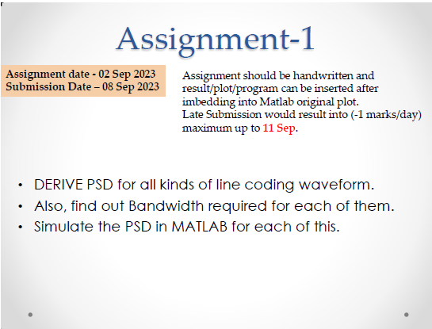

MatLab Code For each UniPolar NRZ,Bipolar NRZ, Manchester, and Amplitude Shift Keying (ASK):

UniPolar NRZ:

% Parameters

bit_rate = 1e6; % Bit rate in bits per second

duration = 1; % Duration of the signal in seconds

voltage_level = 1;

% Generate Unipolar NRZ signal

t = 0:1/bit_rate:duration-1/bit_rate;

data = randi([0, 1], 1, length(t));

signal = voltage_level * data;

% Calculate PSD

fs = bit_rate * 10; % Sampling frequency (oversampling)

psd = abs(fft(signal, fs)).^2 / (length(t) * fs);

% Plot PSD

frequencies = linspace(0, fs, length(psd));

plot(frequencies, 10*log10(psd));

xlabel('Frequency (Hz)');

ylabel('PSD (dB/Hz)');

title('Power Spectral Density of Unipolar NRZ');

Bipolar NRZ:

% Parameters

bit_rate = 1e6; % Bit rate in bits per second

duration = 1; % Duration of the signal in seconds

voltage_level = 1;

% Generate Bipolar NRZ signal

t = 0:1/bit_rate:duration-1/bit_rate;

data = randi([0, 1], 1, length(t));

data(data == 0) = -1; % Convert 0s to -1s

signal = voltage_level * data;

% Calculate PSD

fs = bit_rate * 10; % Sampling frequency (oversampling)

psd = abs(fft(signal, fs)).^2 / (length(t) * fs);

% Plot PSD

frequencies = linspace(0, fs, length(psd));

plot(frequencies, 10*log10(psd));

xlabel('Frequency (Hz)');

ylabel('PSD (dB/Hz)');

title('Power Spectral Density of Bipolar NRZ');

Manchester Encodeing

% Parameters

bit_rate = 1e6; % Bit rate in bits per second

duration = 1; % Duration of the signal in seconds

voltage_level = 1;

% Generate Manchester-encoded signal

t = 0:1/(2*bit_rate):duration-1/(2*bit_rate); % Twice the oversampling

data = randi([0, 1], 1, length(t));

encoded_data = 2 * data - 1; % Convert 0s to -1s and 1s to 1s

signal = voltage_level * kron(encoded_data, [1, -1]);

% Calculate PSD

fs = 2 * bit_rate * 10; % Twice the sampling frequency (oversampling)

psd = abs(fft(signal, fs)).^2 / (length(t) * fs);

% Plot PSD

frequencies = linspace(0, fs, length(psd));

plot(frequencies, 10*log10(psd));

xlabel('Frequency (Hz)');

ylabel('PSD (dB/Hz)');

title('Power Spectral Density of Manchester Encoding');

Amplitude Shift Keying (ASK):

% Parameters

bit_rate = 1e6; % Bit rate in bits per second

duration = 1; % Duration of the signal in seconds

voltage_levels = [0, 1]; % Define voltage levels for 0 and 1

carrier_frequency = 10e6; % Carrier frequency in Hz

modulation_index = 0.5; % Modulation index for ASK

% Generate ASK-modulated signal

t = 0:1/bit_rate:duration-1/bit_rate;

data = randi([0, 1], 1, length(t));

signal = zeros(1, length(t));

for i = 1:length(t)

signal(i) = voltage_levels(data(i) + 1) * cos(2 * pi * carrier_frequency * t(i));

end

% Calculate PSD

fs = bit_rate * 10; % Sampling frequency (oversampling)

psd = abs(fft(signal, fs)).^2 / (length(t) * fs);

% Plot PSD

frequencies = linspace(0, fs, length(psd));

plot(frequencies, 10*log10(psd));

xlabel('Frequency (Hz)');

ylabel('PSD (dB/Hz)');

title('Power Spectral Density of ASK Modulation');